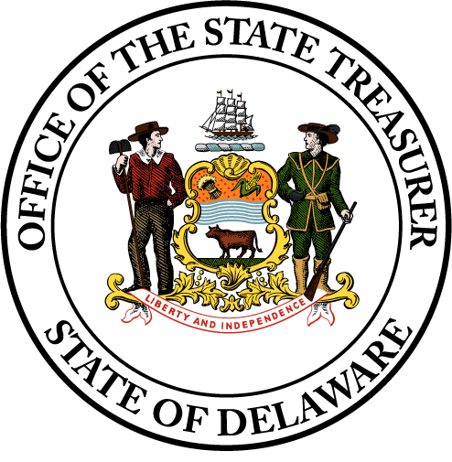



Annual Merchant Checklist

  - Payment Card Industry
  - Data Security Standard (PCI DSS)

Merchant Requirements
Merchants processing credit card payments on behalf of the State of Delaware (the “State”) have accountabilities to the Office of the State Treasurer (“OST”) PCI Team in order for the State to maintain PCI compliance.
Below references a list of items that are to be completed and uploaded by the designated point of contact for each merchant to CampusGuard Portal Document Locker. These items will be reviewed by the OST PCI Team on an annual basis:
- Merchant Survey
  - Review accuracy of equipment list
  - Review accuracy of software/websites/applications used for payment card acceptance in your agency or school district

- Self-Assessment Questionnaire (SAQ) – for authorized wet signature (ex. Director, Superintendent) if needed

- Annual Service Provider compliance review
  - Attestation of Compliance (AOC) for third party service providers

- Merchant Inventory of all devices, workstations, laptops used for inputting cardholder data within section 8 of your Merchant Survey
  - Make/Model
  - Serial Number
  - Description of Use/Purpose

- Merchant Tampering Checklist of all Payment Card Processing Equipment for the last 60 days

- Merchant Payment Systems Procedure Template for State Agencies (to include incident response procedures, procedures for physical security of POS devices, etc.)

- Documented training of all staff members upon hire, and annually thereafter (Contact OST to obtain DLC Training Report)

- Payment Card Handling/Authorization Data Flow Diagram if applicable

- Once all documents mentioned above are completed and uploaded to the CampusGuard Document Locker, you can proceed to lock the SAQ.

